Introduction
All the organizations nowadays began to value the data they have and consider it as a company asset if used properly. The data is like a raw material that needs to be cleaned, prepared and processed before start analysing it. These data can tremendously affect the future of the organization as it is used to support decision making in the company. There are many ways to utilise the data as reports to provide facts and information regarding the past, present and future of the enterprise. This is referred to as Business Analytics which consist of descriptive, predictive and prescriptive analysis. The descriptive analysis is where we use the data to demonstrate facts about customers, income, expenses etc. Online Analytics Processing (OLAP) or also known as business intelligence is a branch of descriptive analysis. This term refers to the processing and abstracting the data from a business database to identify areas for improvement and provide reports to the stakeholders for better decision-making (Ramesh, 2020). There are three main managerial report that can be implemented in OLAP:
- Matric Managerial Reports: KPI that needs to be tracked and set a target for it.
- Dashboard-Type Reports: a set of reports in one page with different plots.
- Balanced Scored-Type Reports: used to examine the company’s performance from different aspects (Ramesh, 2020).
In this report we are going to focus on the second type of managerial reports and try to build a dashboard that supports the decisionmakers. Dashboard is a group of graphs added together in one page that serve the same goal and lay down a story to help the reader to comprehend the information. Like any stories, the dashboard will have characters, drama (challenge), a message and a solution.
We are going to build a dashboard that tell a story about the crime data we have. The KPI that this dashboard supports are to identify the crime hotspots and analyse the potential justification for this phenomena. The data has been extracted from police departments all around England and it covers information from many aspects like the reported crime, witness, crime type, police employees and station. the image below shows how these tables are connected.
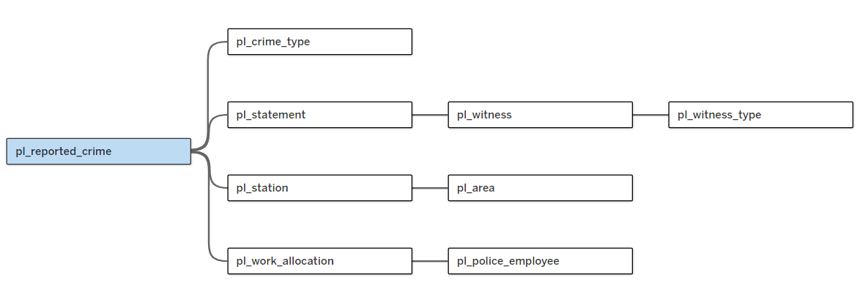
Now let’s start building our dashboard and we will go through them one by one to explain what is happening in each graph. In the beginning, we need to see what the number of crimes per station is to identify the highest crime hotspot and the crime type. We choose stacked bar chart as it allows us to compare the different categories and also can take the numerical values. Additionally, the possibility of handling multiple dimensions resulting in a more comprehensive visualization (Ramesh, 2020). This chart has the crime type in the y-axis with different colours and the no of crime in the x-axis. The x-axis is divided into four sections, one for each area. The bar chart shows that by far Meanwood has the highest crime in nearly all the crime types. Furthermore, violent crime is the most common crime in the area as well as in Lawnswood.
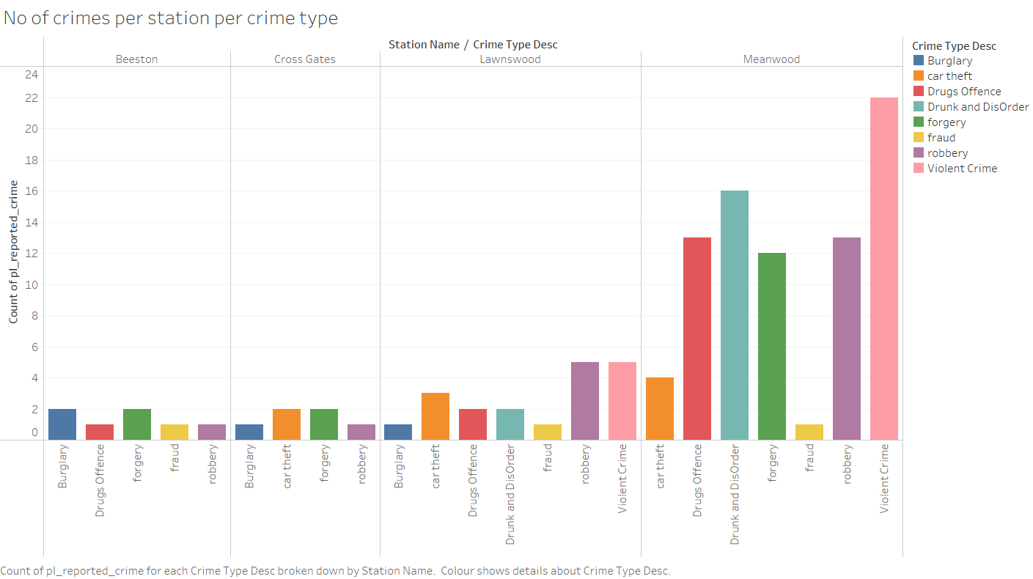
To better understand how the police department is dealing with each crime type and whether it is a lack of resources that we are dealing with, we want to know how many police officers are assigned to each crime type. To achieve this, we used tree map to measure the number of crimes and work allocations per crime type. The tree map is suitable here because it makes it easy to identify patterns, highest and lowest vales along side with different dimensions. It is evidence that violent crime takes the highest amount of work allocation, and it is the most reported crime.
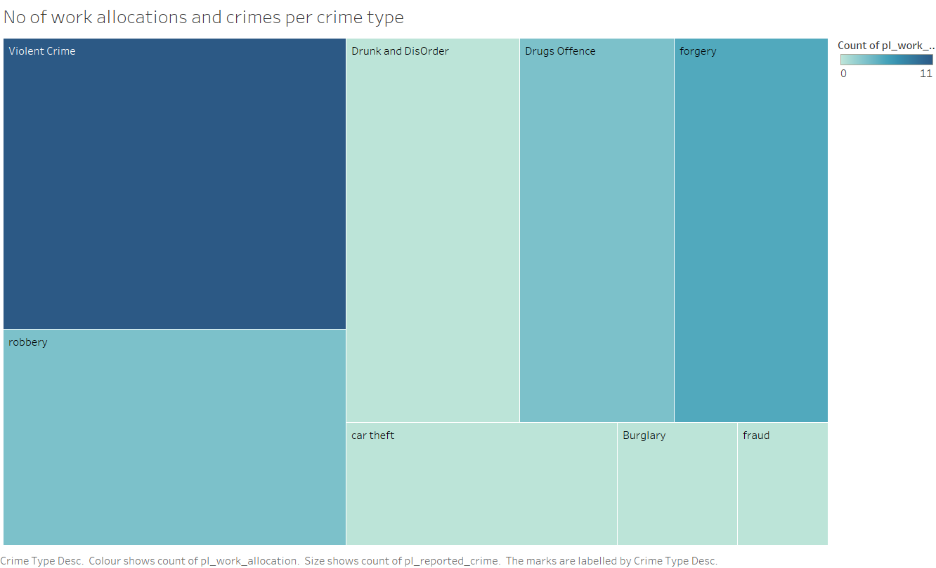
The police is giving all the support needed to tackle violent crimes as the previous plot showed. There are other factors that can facilitate dealing with crime which is a crime witness. Having a witness in crime investigation can provide the officer with a lot of information. So, let’s see how many witnesses there are in each crime type in total. The below heat map compares to categorical values where both x and y-axis are categories and the values in the middle in different colure to show strength. As we can see, violent crime has the highest amount of witness compared with all the other crime type.
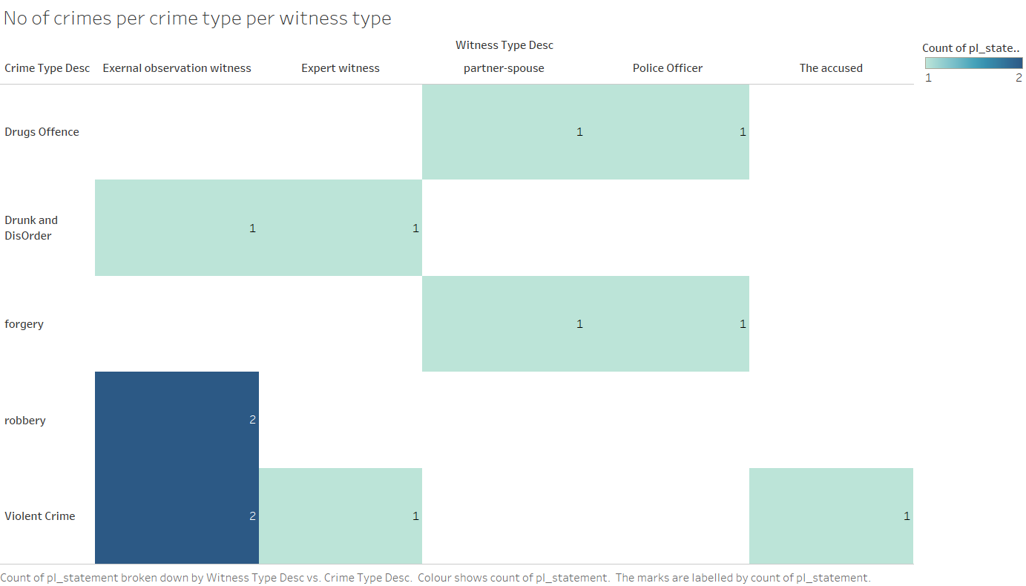
Now let’s see how many works allocation is there for each crime type. This will help us see if police are giving more resources to a specific kind of witness and what is the lowest. The bar chart demonstrates that police is giving more work allocation when the witness is external observation. Moreover, having no witness in a crime results in less work allocation.
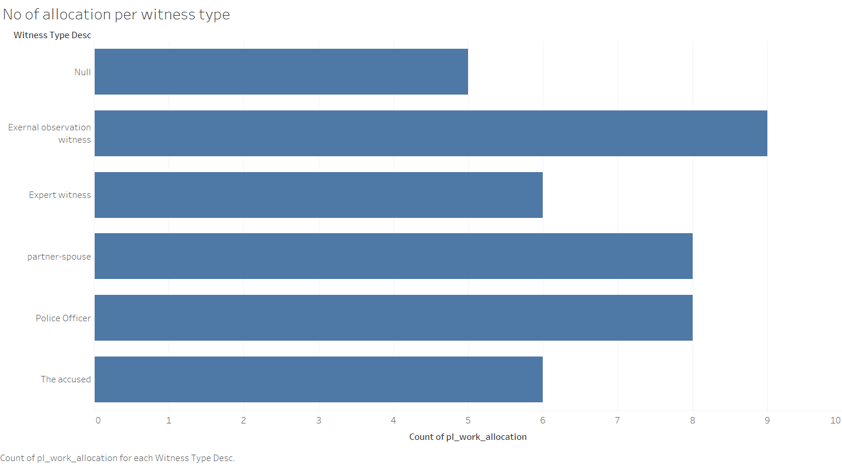
We made scatter plot with three different categories: crime status, station name and crime type. This plot allows the decision maker to see what area has more opened crimes and the type of crime. This way they can manage their resources more effectively

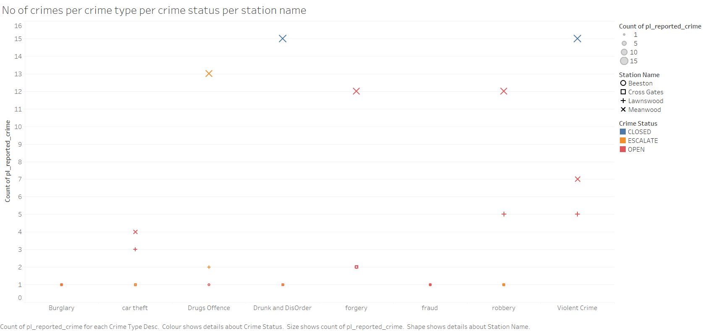

This dashboard is built to assist the decision makers to easily understand and identify the hotspots crimes. Staring from understanding where the crime is to find out the crime circumstances and finally make the best decision to minimize the crime in the station.

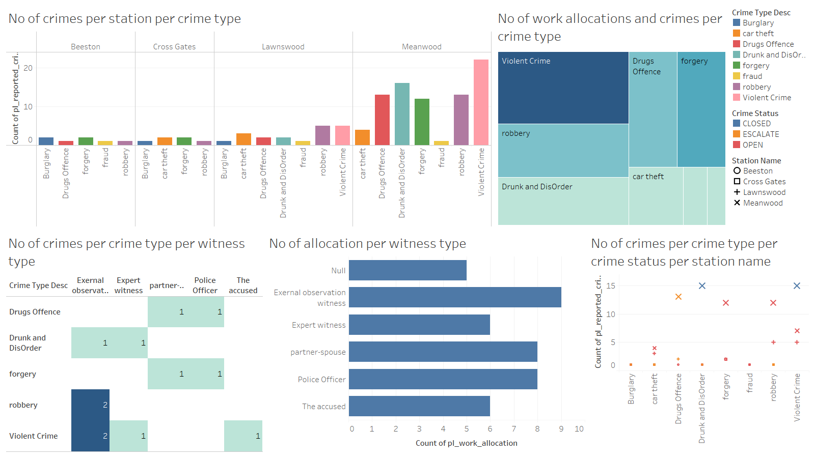

Creating a Procedure:
We are going to create a procedure that support updating the crime table. This procedure will contribute to save time for changing the crime status and minimise the errors and user friendly. The procedure will deal with many potential mistakes that could happen while updating the crime status:
- Taking only three categories: OPEN, CLOSED and ESCALATE. This will prevent any typo to go to the database.
- Update the date closed when updating to CLOSED as every closed crime has a closing date.
- Prevent overwrite. In this case, if someone tries to update a closed crime when it is already closed it won’t allow it. That is because the date close will change and the accurate date will be removed.
- Do not take ID that dose not exist in the table and will provide a message that tell the user that the ID does not exist.
- A default parameter as OPEN for better use.
- The removal of the close date when updating from closed to something else.
- An appropriate message that explains the error when encountering one.
The procedure:
CREATE OR REPLACE PROCEDURE change_crime_status(
REPORTED_CRIME_ID_in IN NUMBER,
CRIME_STATUS_in IN PL_REPORTED_CRIME.CRIME_STATUS%TYPE DEFAULT 'OPEN' -- Default value
)
AS
-- Custom exceptions
INVALID_STATUS EXCEPTION;
INVALID_CRIME_ID EXCEPTION;
SAME_STATUS_ERROR EXCEPTION;

-- Variables to hold current values
v_current_status PL_REPORTED_CRIME.CRIME_STATUS%TYPE;
v_crime_count NUMBER;
BEGIN
-- Validate the reported crime ID
SELECT COUNT(*)
INTO v_crime_count
FROM PL_REPORTED_CRIME
WHERE REPORTED_CRIME_ID = REPORTED_CRIME_ID_in;

IF v_crime_count = 0 THEN
RAISE INVALID_CRIME_ID; -- Raise exception if the ID doesn't exist
END IF;

-- Fetch the current crime status
SELECT CRIME_STATUS
INTO v_current_status
FROM PL_REPORTED_CRIME
WHERE REPORTED_CRIME_ID = REPORTED_CRIME_ID_in;

-- Prevent overwriting the same status
IF v_current_status = CRIME_STATUS_in THEN
RAISE SAME_STATUS_ERROR; -- Raise exception if the new status is the same as the current status
END IF;

-- Validate the input status
IF CRIME_STATUS_in NOT IN ('OPEN', 'CLOSED', 'ESCALATE') THEN
RAISE INVALID_STATUS; -- Raise exception if invalid status
END IF;

-- Handle status changes
IF v_current_status = 'CLOSED' AND CRIME_STATUS_in != 'CLOSED' THEN
-- Update status and reset DATE_CLOSED to NULL
UPDATE PL_REPORTED_CRIME
SET CRIME_STATUS = CRIME_STATUS_in,
DATE_CLOSED = NULL
WHERE REPORTED_CRIME_ID = REPORTED_CRIME_ID_in;
ELSIF CRIME_STATUS_in = 'CLOSED' THEN
-- Update status and set DATE_CLOSED to the current date
UPDATE PL_REPORTED_CRIME
SET CRIME_STATUS = CRIME_STATUS_in,
DATE_CLOSED = SYSDATE
WHERE REPORTED_CRIME_ID = REPORTED_CRIME_ID_in;
ELSE
-- Update status without changing DATE_CLOSED
UPDATE PL_REPORTED_CRIME
SET CRIME_STATUS = CRIME_STATUS_in
WHERE REPORTED_CRIME_ID = REPORTED_CRIME_ID_in;
END IF;

-- Optionally, provide feedback
DBMS_OUTPUT.PUT_LINE('Crime status updated successfully for ID: ' || REPORTED_CRIME_ID_in);

EXCEPTION
WHEN INVALID_CRIME_ID THEN
-- Handle the custom exception for invalid crime ID
DBMS_OUTPUT.PUT_LINE('Error: Reported Crime ID ' || REPORTED_CRIME_ID_in || ' does not exist.');
WHEN SAME_STATUS_ERROR THEN
-- Handle the custom exception for same status update
DBMS_OUTPUT.PUT_LINE('Error: The new crime status is the same as the current status. Update not allowed.');
WHEN INVALID_STATUS THEN
-- Handle the custom exception for invalid status
DBMS_OUTPUT.PUT_LINE('Error: Invalid crime status. Allowed values are "OPEN", "CLOSED", or "ESCALATE".');
WHEN OTHERS THEN
-- Handle any other exceptions
DBMS_OUTPUT.PUT_LINE('Error updating crime status: ' || SQLERRM);
END;
/
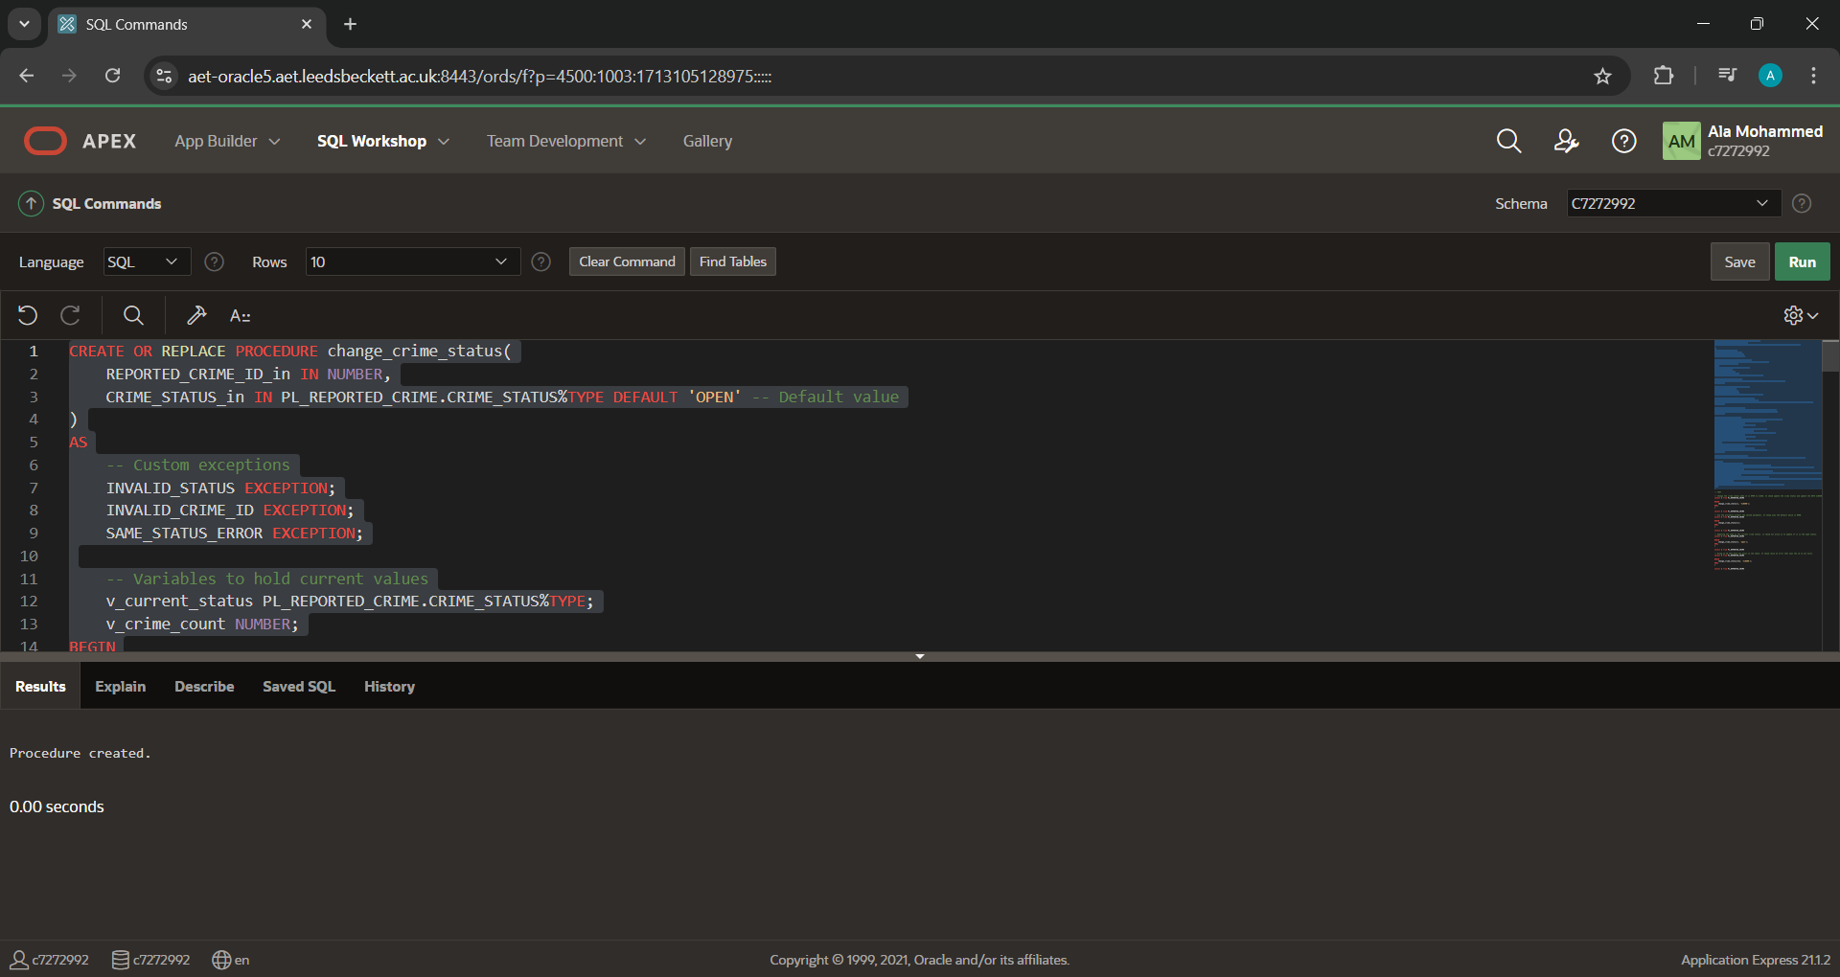
Now let’s test the procedure.
-- TEST

-- Change the crime status when it is OPEN to CLOSE. It shoud update the crime status and update the DATE CLOSED. ID 1 is currently OPEN.
BEGIN
change_crime_status(1, 'CLOSED');
END;
/
select * from PL_REPORTED_CRIME
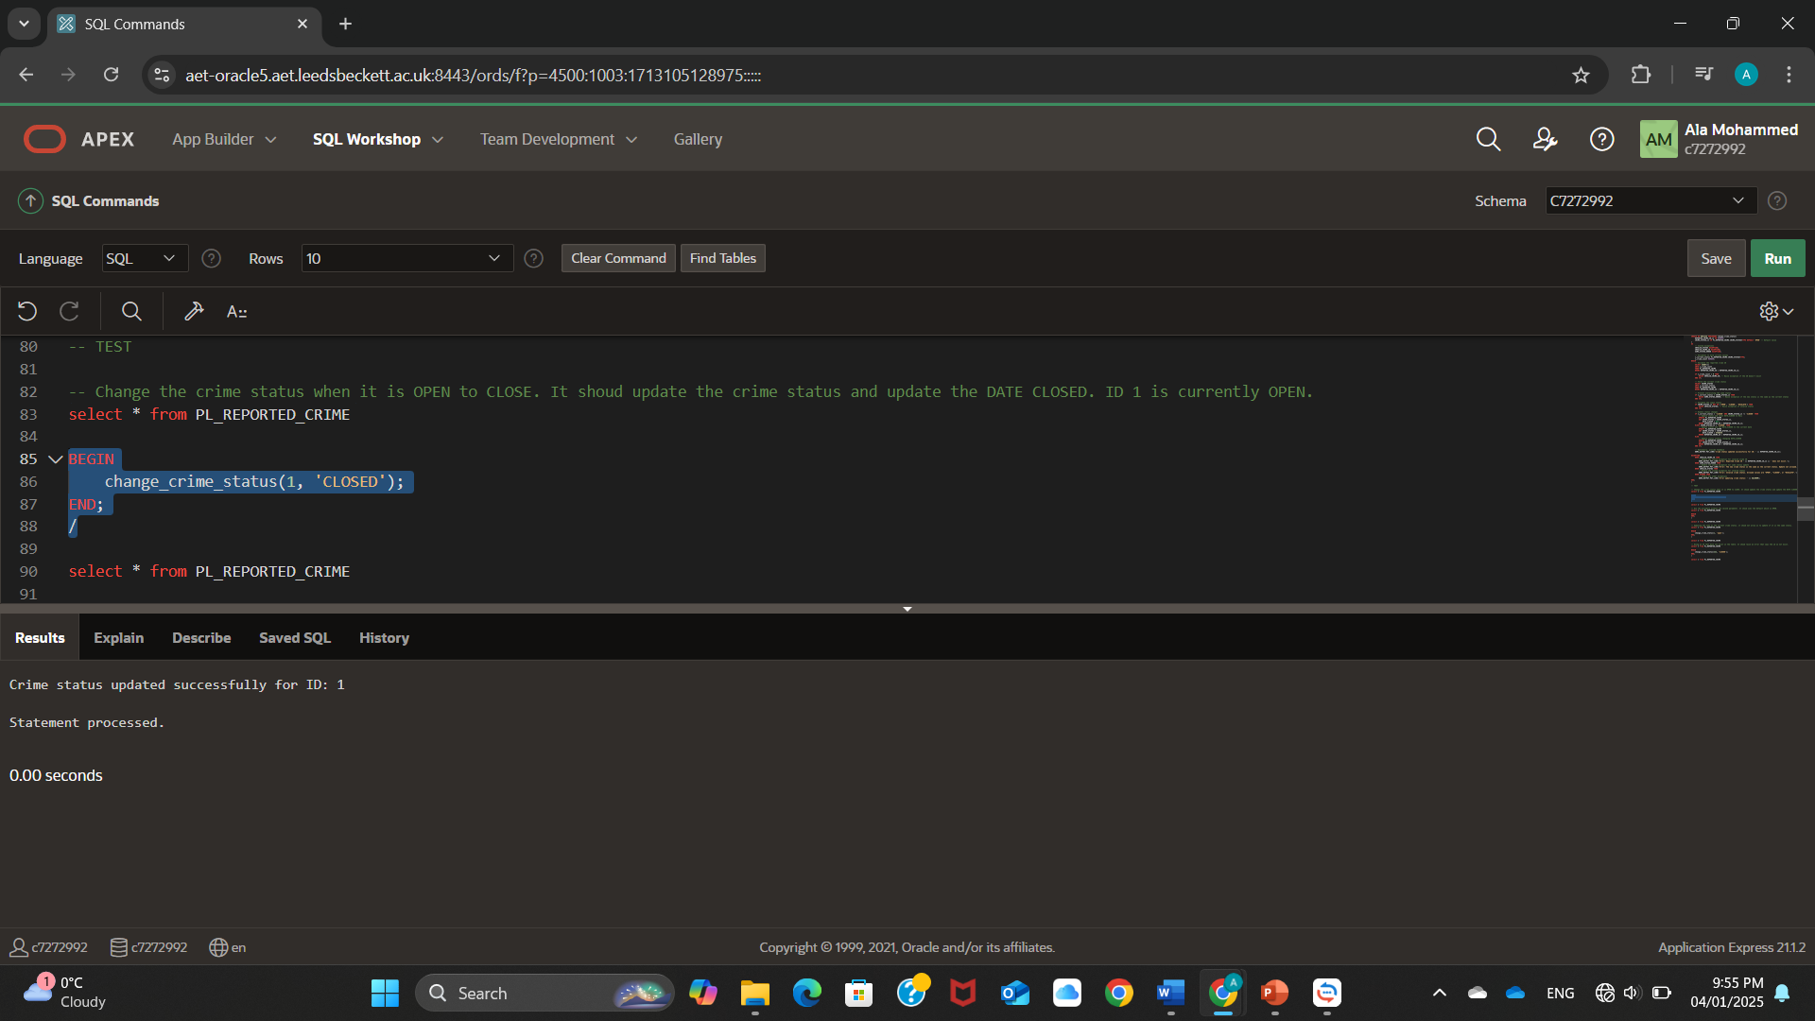
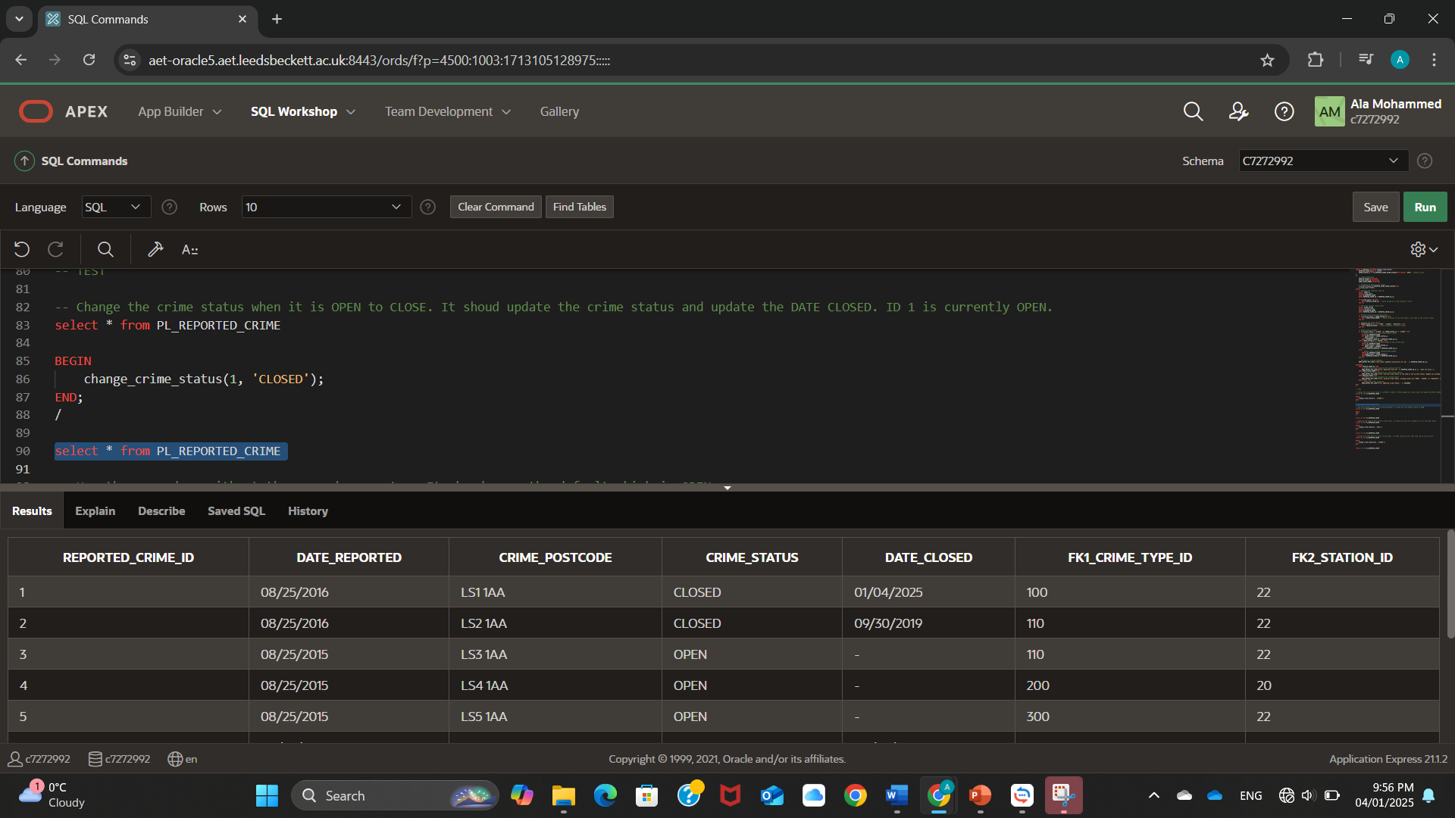

- Use the procedure without the second parameter. It shoud uses the default which is OPEN.
BEGIN
change_crime_status(1);
END;
/
select * from PL_REPORTED_CRIME
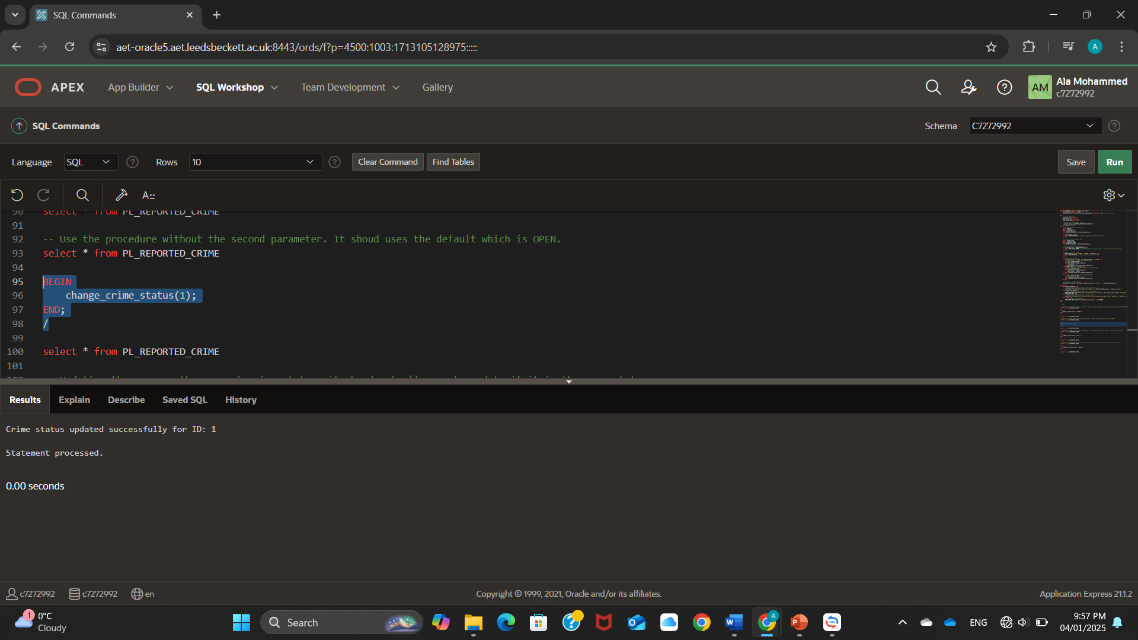
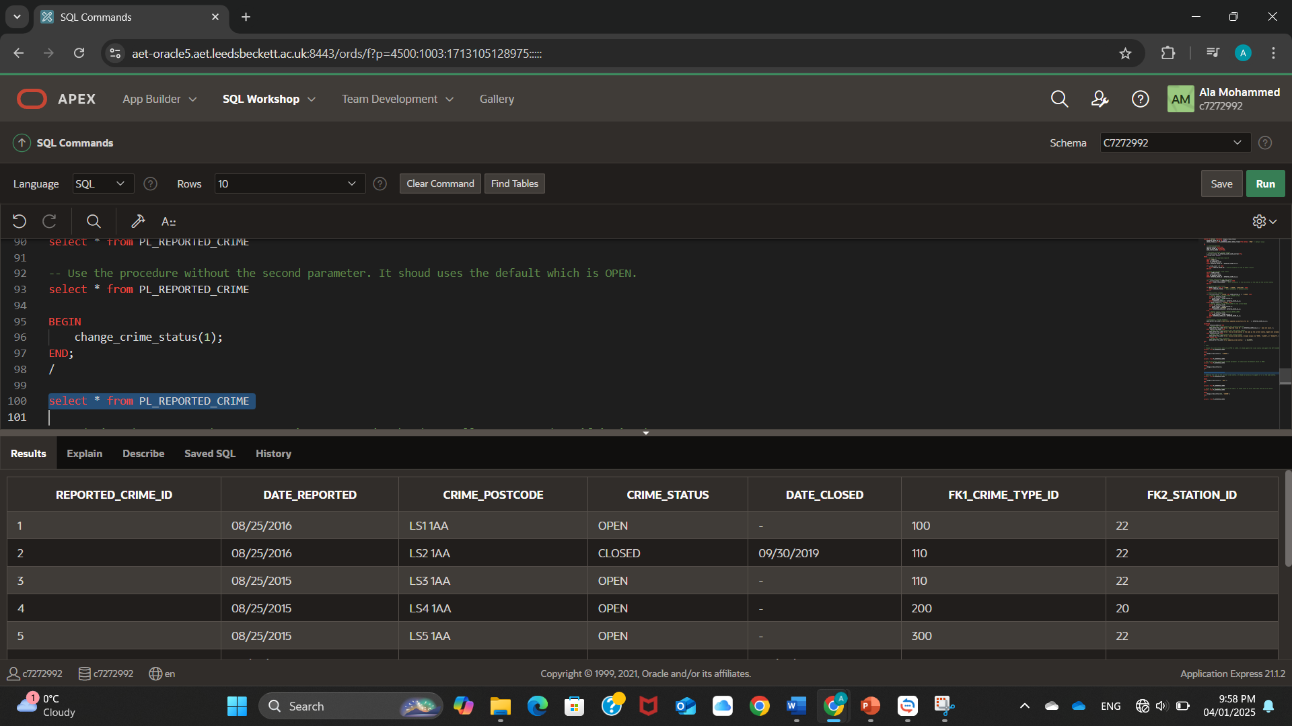

- Updating the same as the current crime status. it shoud not allow us to update if it is the same status.
BEGIN
change_crime_status(1, 'open');
END;
/

select * from PL_REPORTED_CRIME
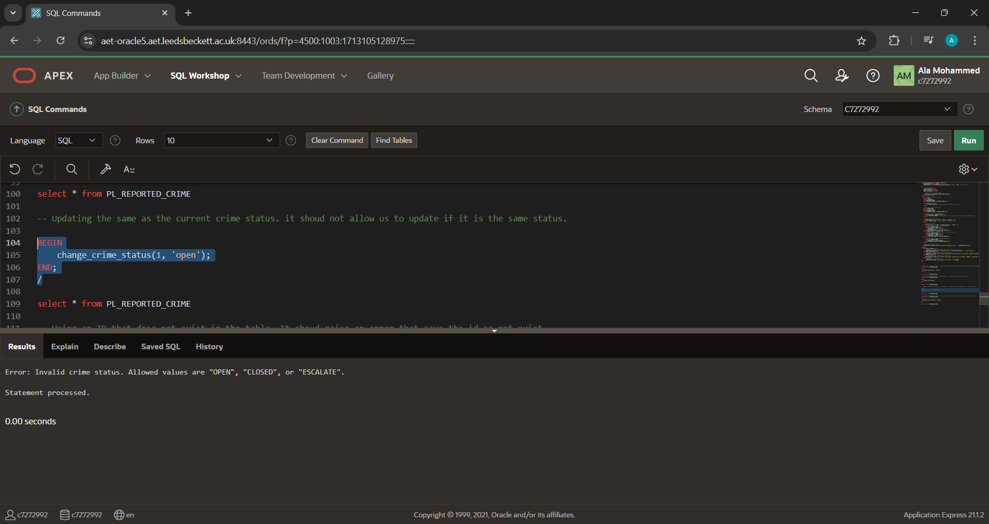

- Using an ID that dose not exist in the table. It shoud raise an error that says the id so not exist.
BEGIN
change_crime_status(222, 'CLOSED');
END;
/
select * from PL_REPORTED_CRIME
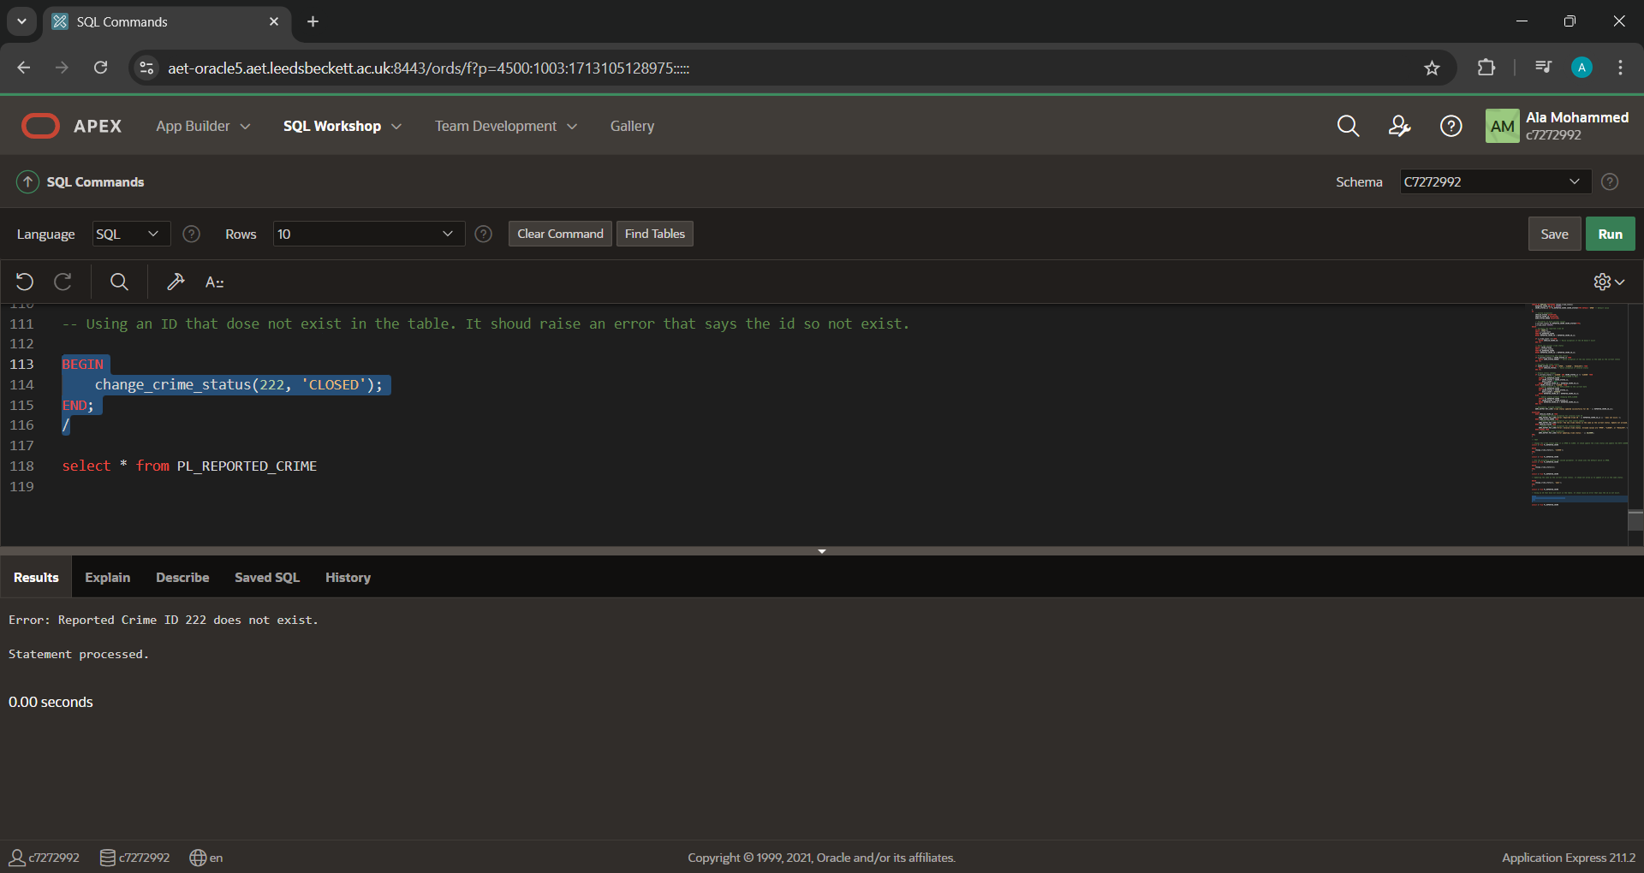

Creating a function:
Now we will create a function facilitate the stakeholder to find out how long a crime has been open for. This function will save time and provide a significant information about a crime duration. If we are going to write a code for it, it will be long and time consuming and not very efficient. The query will look like this:
SELECT
REPORTED_CRIME_ID,
DATE_REPORTED,
DATE_CLOSED,
DATE_CLOSED - DATE_REPORTED AS duration_in_days
FROM pl_reported_crime
WHERE REPORTED_CRIME_ID = 3;

This code will not give an output if the crime still open or escalated as they have no date_closed. Moreover, if we want the code to give us a round up number, we have to add a function to do that for us because sometimes the output come with a very large decimal number. The function we built deals with all that and more:
- Raise an error with an explanation when the ID does not exist.
- Uses the sysdate function if there is no date_closed which is the case to all the ‘open’ and ‘escalated’ crimes.
- Round up the number to two decimal places.
- Give the duration in days or months depending on the input. With a default input of ‘DAYS’.
- If something other than days or months entered, a message will be generated explaining what the function can take.
The function:
CREATE OR REPLACE FUNCTION calculate_crime_duration(
reported_crime_id_in IN NUMBER,
duration_unit_in IN VARCHAR2 DEFAULT 'DAYS' -- 'DAYS' or 'MONTHS'
) RETURN NUMBER
AS
v_duration NUMBER;
v_date_reported DATE;
v_date_closed DATE;
BEGIN
-- Query to get the DATE_REPORTED and DATE_CLOSED (or use SYSDATE if DATE_CLOSED is NULL)
SELECT DATE_REPORTED,
NVL(DATE_CLOSED, SYSDATE) -- Use SYSDATE if DATE_CLOSED is NULL
INTO v_date_reported, v_date_closed
FROM pl_reported_crime
WHERE REPORTED_CRIME_ID = reported_crime_id_in;

-- Check the value of duration_unit_in and calculate the duration accordingly
IF duration_unit_in = 'DAYS' THEN
-- Calculate duration in days
v_duration := v_date_closed - v_date_reported;
ELSIF duration_unit_in = 'MONTHS' THEN
-- Calculate duration in months
v_duration := MONTHS_BETWEEN(v_date_closed, v_date_reported);
ELSE
-- Raise an error if the duration_unit_in is not 'DAYS' or 'MONTHS'
RAISE_APPLICATION_ERROR(-20003, 'Invalid duration unit: ''' || duration_unit_in || '''. Please use ''DAYS'' or ''MONTHS''.');
END IF;

-- Round the duration to 2 decimal places
v_duration := ROUND(v_duration, 2);

-- Return the duration
RETURN v_duration;

EXCEPTION
WHEN NO_DATA_FOUND THEN
-- Raise an error if no record is found
RAISE_APPLICATION_ERROR(-20001, 'Error: REPORTED_CRIME_ID ' || reported_crime_id_in || ' does not exist.');
WHEN OTHERS THEN
-- Handle any other exceptions
RAISE_APPLICATION_ERROR(-20002, 'Unexpected error occurred: ' || SQLERRM);
END;
/

Now let’s test the function:
-- TEST
- if the crime has a close date. it should use the date provided in the dataset. crime 2 is closed crime.
SELECT calculate_crime_duration(2, 'MONTHS') AS duration_in_days FROM dual;
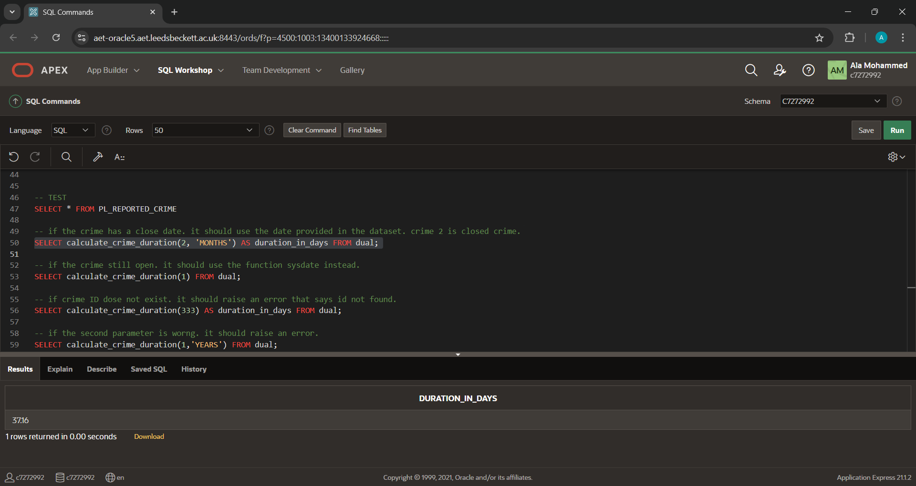
-- if the crime still open. it should use the function sysdate instead.
SELECT calculate_crime_duration(1) FROM dual;
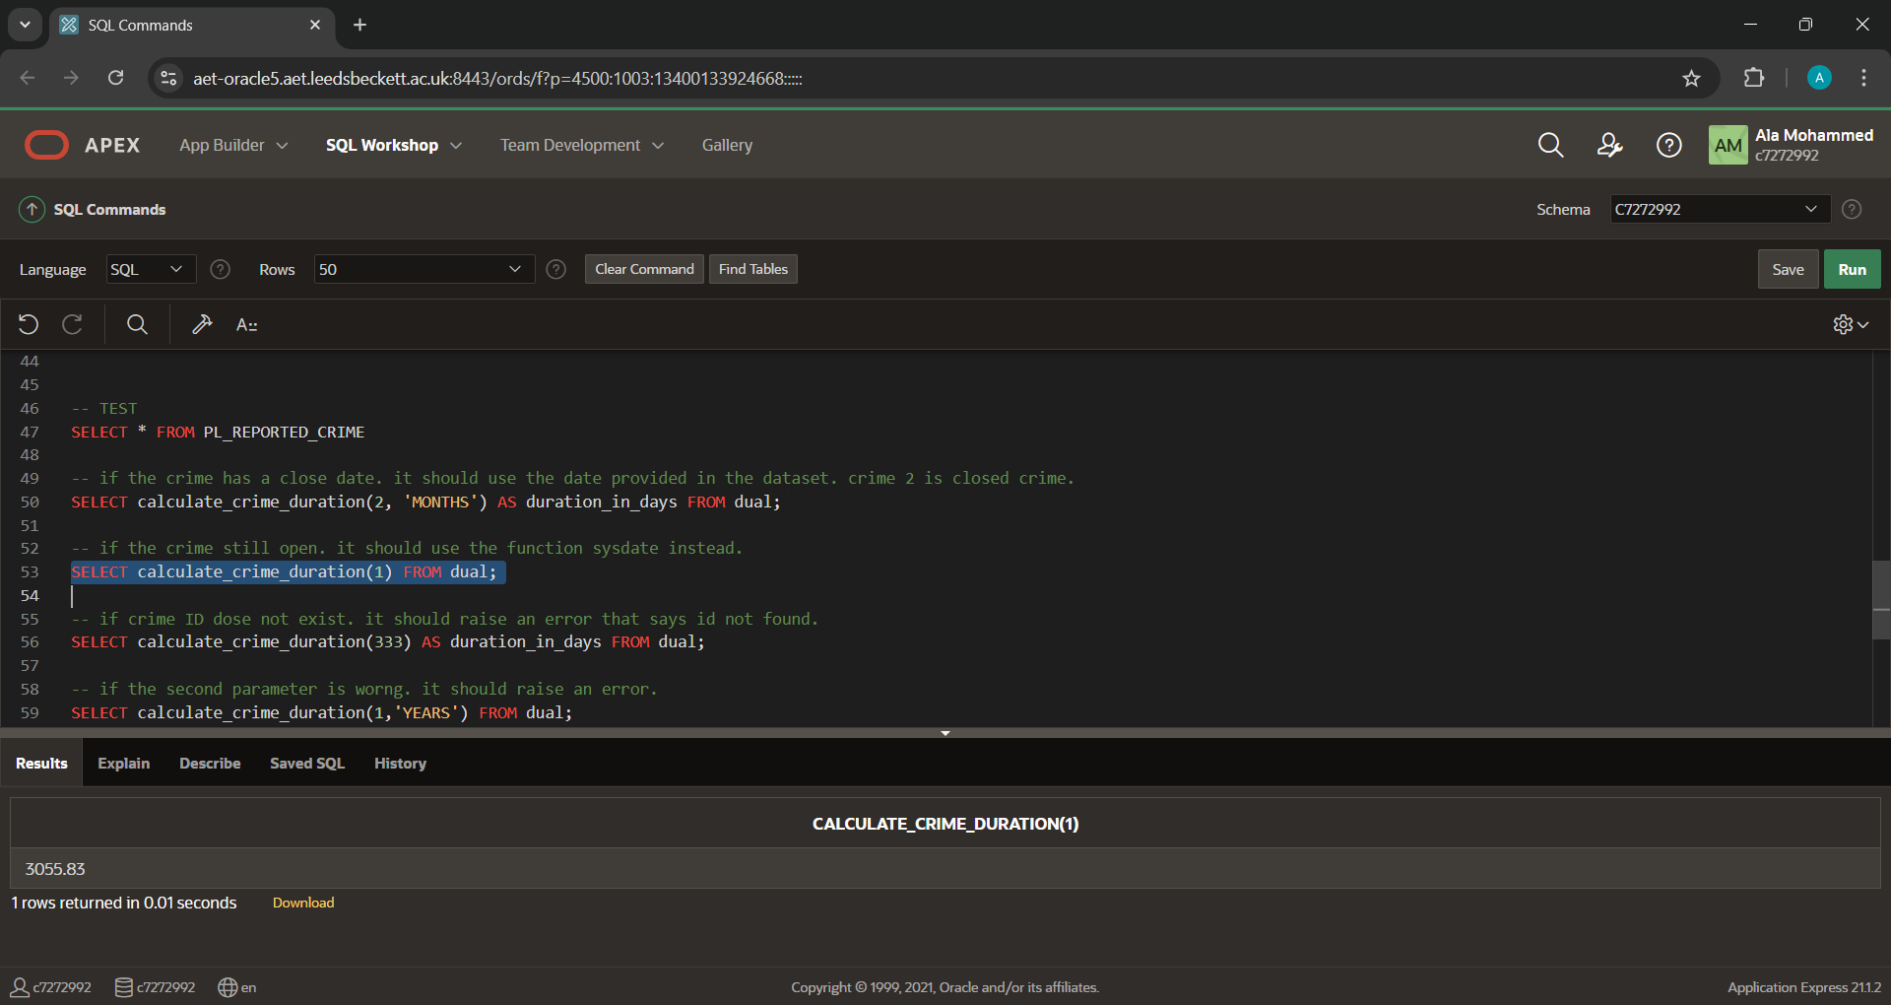
- if crime ID dose not exist. it should raise an error that says id not found.
SELECT calculate_crime_duration(333) AS duration_in_days FROM dual;
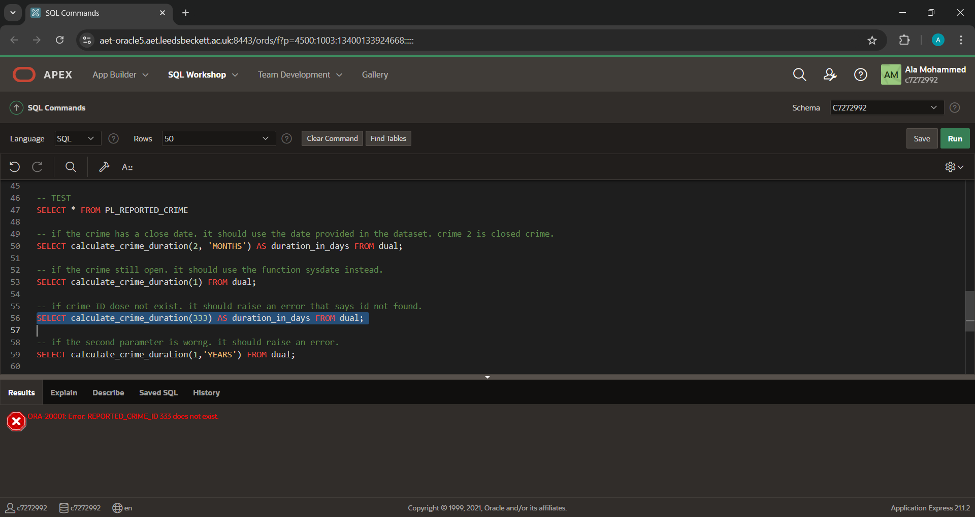
-- if the second parameter is worng. it should raise an error.
SELECT calculate_crime_duration(1,'YEARS') FROM dual;

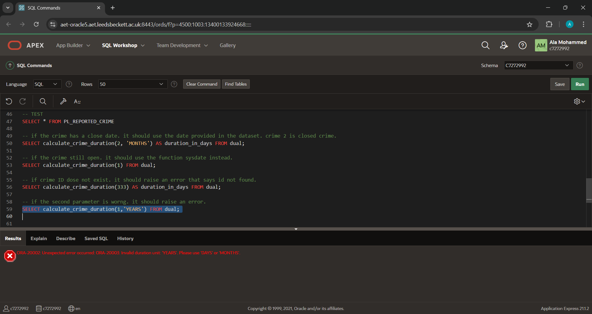

Creating a package:
The package is going to save all the related procedure and function together for better access.
create or replace PACKAGE crime_package AS
-- Function to calculate crime duration
FUNCTION calculate_crime_duration(
reported_crime_id_in IN NUMBER,
duration_unit_in IN VARCHAR2 DEFAULT 'DAYS' -- 'DAYS' or 'MONTHS'
) RETURN NUMBER;

-- Procedure to change crime status
PROCEDURE change_crime_status(
REPORTED_CRIME_ID_in IN NUMBER,
CRIME_STATUS_in IN PL_REPORTED_CRIME.CRIME_STATUS%TYPE DEFAULT 'OPEN' -- Default value
);

PROCEDURE delete_reported_crime(
REPORTED_CRIME_ID_in IN NUMBER
);
END crime_package;

create or replace PACKAGE BODY crime_package AS
-- Function to calculate crime duration
FUNCTION calculate_crime_duration(
reported_crime_id_in IN NUMBER,
duration_unit_in IN VARCHAR2 DEFAULT 'DAYS' -- 'DAYS' or 'MONTHS'
) RETURN NUMBER
AS
v_duration NUMBER;
v_date_reported DATE;
v_date_closed DATE;
BEGIN
-- Query to get the DATE_REPORTED and DATE_CLOSED (or use SYSDATE if DATE_CLOSED is NULL)
SELECT DATE_REPORTED,
NVL(DATE_CLOSED, SYSDATE) -- Use SYSDATE if DATE_CLOSED is NULL
INTO v_date_reported, v_date_closed
FROM pl_reported_crime
WHERE REPORTED_CRIME_ID = reported_crime_id_in;

-- Check the value of duration_unit_in and calculate the duration accordingly
IF duration_unit_in = 'DAYS' THEN
-- Calculate duration in days
v_duration := v_date_closed - v_date_reported;
ELSIF duration_unit_in = 'MONTHS' THEN
-- Calculate duration in months
v_duration := MONTHS_BETWEEN(v_date_closed, v_date_reported);
ELSE
-- Raise an error if the duration_unit_in is not 'DAYS' or 'MONTHS'
RAISE_APPLICATION_ERROR(-20003, 'Invalid duration unit: ''' || duration_unit_in || '''. Please use ''DAYS'' or ''MONTHS''.');
END IF;

-- Round the duration to 2 decimal places
v_duration := ROUND(v_duration, 2);

-- Return the duration
RETURN v_duration;

EXCEPTION
WHEN NO_DATA_FOUND THEN
-- Raise an error if no record is found
RAISE_APPLICATION_ERROR(-20001, 'Error: REPORTED_CRIME_ID ' || reported_crime_id_in || ' does not exist.');
WHEN OTHERS THEN
-- Handle any other exceptions
RAISE_APPLICATION_ERROR(-20002, 'Unexpected error occurred: ' || SQLERRM);
END calculate_crime_duration;

-- Procedure to change crime status
PROCEDURE change_crime_status(
REPORTED_CRIME_ID_in IN NUMBER,
CRIME_STATUS_in IN PL_REPORTED_CRIME.CRIME_STATUS%TYPE DEFAULT 'OPEN' -- Default value
)
AS
-- Custom exceptions
INVALID_STATUS EXCEPTION;
INVALID_CRIME_ID EXCEPTION;
SAME_STATUS_ERROR EXCEPTION;

-- Variables to hold current values
v_current_status PL_REPORTED_CRIME.CRIME_STATUS%TYPE;
v_crime_count NUMBER;
BEGIN
-- Validate the reported crime ID
SELECT COUNT(*)
INTO v_crime_count
FROM PL_REPORTED_CRIME
WHERE REPORTED_CRIME_ID = REPORTED_CRIME_ID_in;

IF v_crime_count = 0 THEN
RAISE INVALID_CRIME_ID; -- Raise exception if the ID doesn't exist
END IF;

-- Fetch the current crime status
SELECT CRIME_STATUS
INTO v_current_status
FROM PL_REPORTED_CRIME
WHERE REPORTED_CRIME_ID = REPORTED_CRIME_ID_in;

-- Prevent overwriting the same status
IF v_current_status = CRIME_STATUS_in THEN
RAISE SAME_STATUS_ERROR; -- Raise exception if the new status is the same as the current status
END IF;

-- Validate the input status
IF CRIME_STATUS_in NOT IN ('OPEN', 'CLOSED', 'ESCALATE') THEN
RAISE INVALID_STATUS; -- Raise exception if invalid status
END IF;

-- Handle status changes
IF v_current_status = 'CLOSED' AND CRIME_STATUS_in != 'CLOSED' THEN
-- Update status and reset DATE_CLOSED to NULL
UPDATE PL_REPORTED_CRIME
SET CRIME_STATUS = CRIME_STATUS_in,
DATE_CLOSED = NULL
WHERE REPORTED_CRIME_ID = REPORTED_CRIME_ID_in;
ELSIF CRIME_STATUS_in = 'CLOSED' THEN
-- Update status and set DATE_CLOSED to the current date
UPDATE PL_REPORTED_CRIME
SET CRIME_STATUS = CRIME_STATUS_in,
DATE_CLOSED = SYSDATE
WHERE REPORTED_CRIME_ID = REPORTED_CRIME_ID_in;
ELSE
-- Update status without changing DATE_CLOSED
UPDATE PL_REPORTED_CRIME
SET CRIME_STATUS = CRIME_STATUS_in
WHERE REPORTED_CRIME_ID = REPORTED_CRIME_ID_in;
END IF;

-- Optionally, provide feedback
DBMS_OUTPUT.PUT_LINE('Crime status updated successfully for ID: ' || REPORTED_CRIME_ID_in);

EXCEPTION
WHEN INVALID_CRIME_ID THEN
-- Handle the custom exception for invalid crime ID
DBMS_OUTPUT.PUT_LINE('Error: Reported Crime ID ' || REPORTED_CRIME_ID_in || ' does not exist.');
WHEN SAME_STATUS_ERROR THEN
-- Handle the custom exception for same status update
DBMS_OUTPUT.PUT_LINE('Error: The new crime status is the same as the current status. Update not allowed.');
WHEN INVALID_STATUS THEN
-- Handle the custom exception for invalid status
DBMS_OUTPUT.PUT_LINE('Error: Invalid crime status. Allowed values are "OPEN", "CLOSED", or "ESCALATE".');
WHEN OTHERS THEN
-- Handle any other exceptions
DBMS_OUTPUT.PUT_LINE('Error updating crime status: ' || SQLERRM);
END change_crime_status;

PROCEDURE delete_reported_crime(
REPORTED_CRIME_ID_in IN NUMBER
)
AS
BEGIN
DELETE FROM pl_reported_crime
WHERE reported_crime_id = REPORTED_CRIME_ID_in;
END delete_reported_crime;

END crime_package;

To test the package we will run some lines.
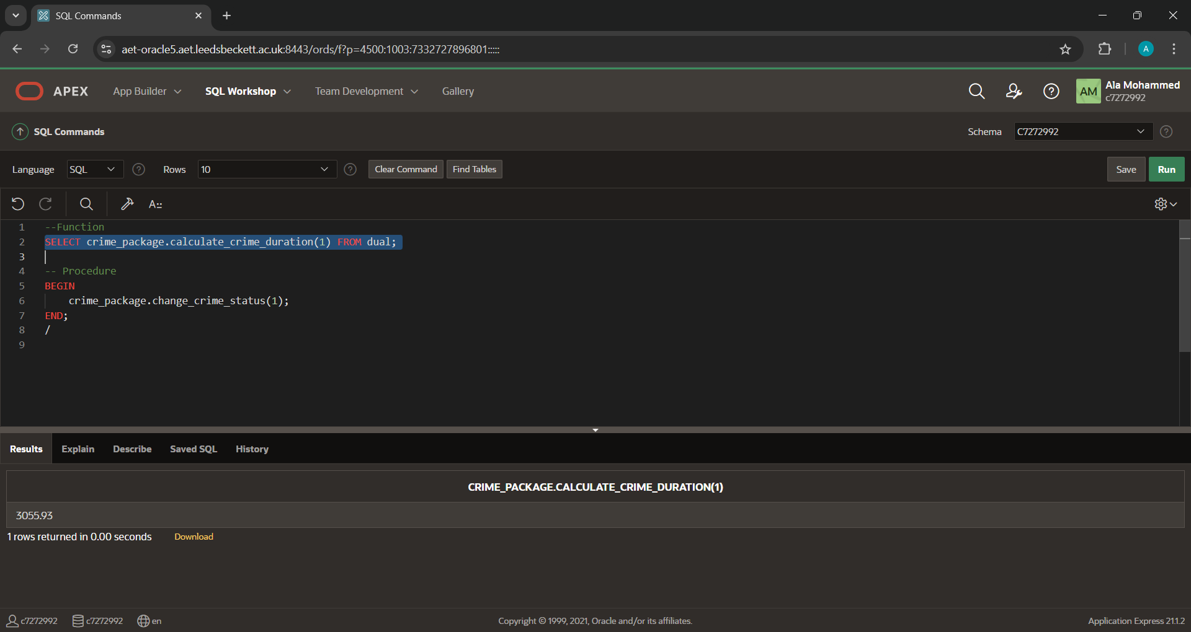
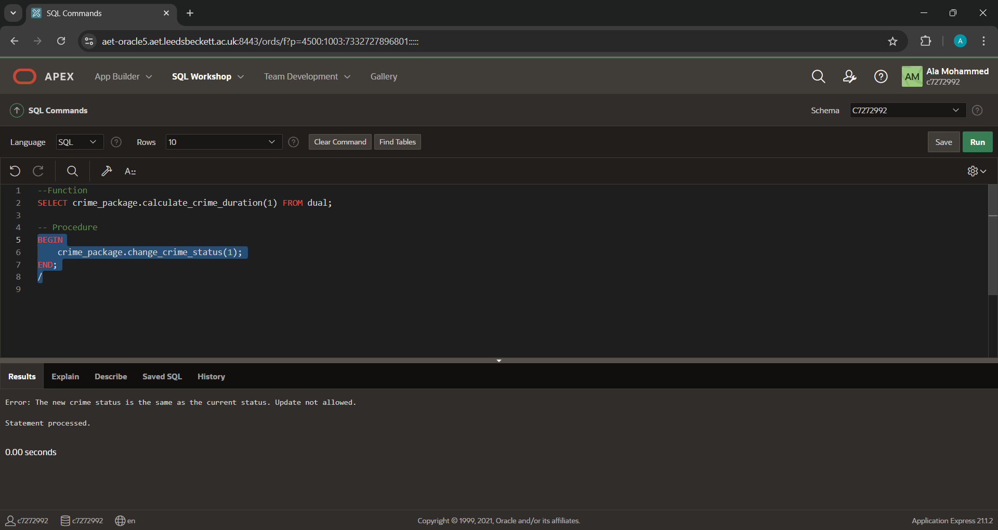

In application:

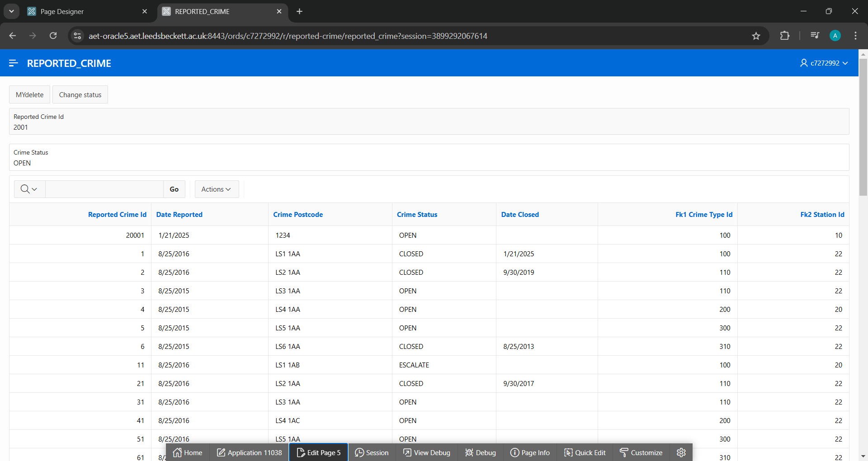
Now we going to use the bottom we created ‘crime status’ to change the first row to be closed and also add the date of update to the ‘Date closed’.
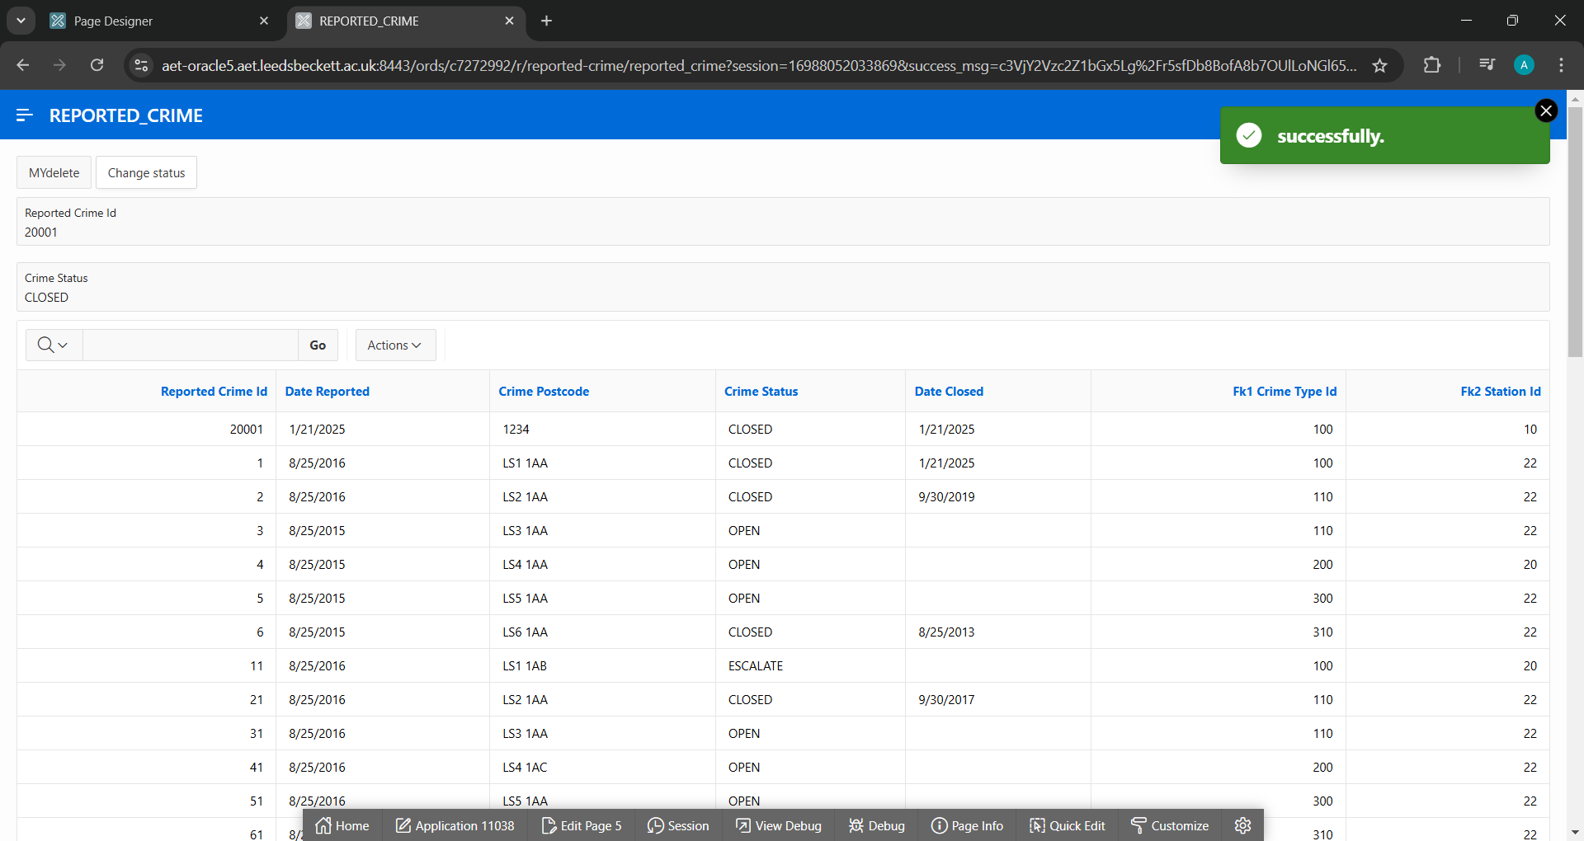

Now the other bottom which is ‘MYdelete’. Will remove the first row:
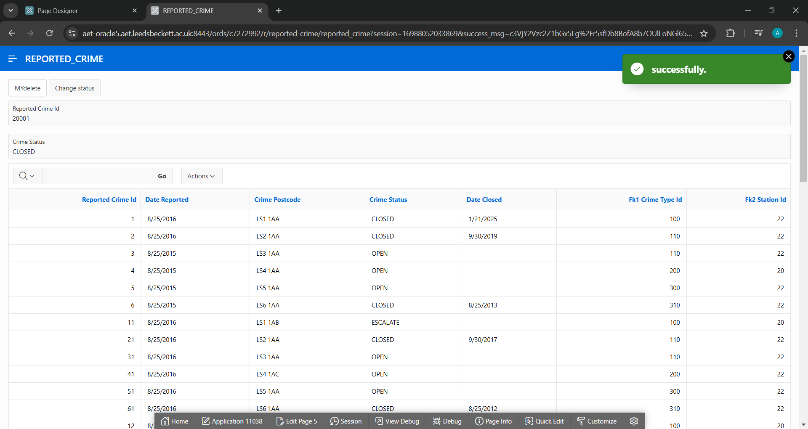
The code we used for these bottoms:
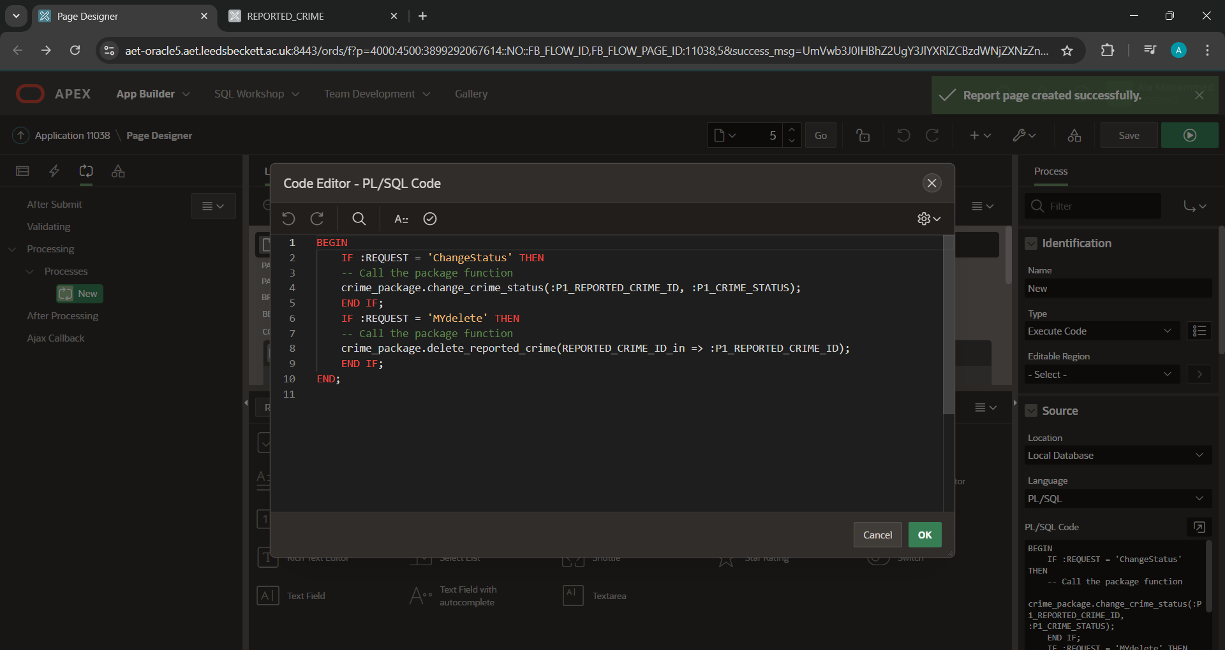

Reference:
Ramesh, S. (2020) Nature of Data, Statistical Modeling, and Visualization. In: Analytics, Data Science, & Artificial Intelligence: Systems for Decision Support, Global Edition. UK: Pearson Education, pp.153-228.

